**Project Management System**

**First Sprint**

**Designed For**

Professor Lawrence Stein

Project Management Institute

**Designed by**

Vartan Kazaryan – Database Design

Milaud – GUI Design

Luke

Kian

Iman

**Table of Contents**

1. **Storyboard**
   1. Deliverables
   2. Requirements
   3. Tasks
   4. Issues
   5. Resources
2. **High Level Design**
   1. Class Diagrams
      1. Deliverables
      2. Requirements (has nested classes)
      3. Tasks
      4. Resources (has nested classes)
      5. Issues
      6. Action Items
      7. Decisions
   2. Use Case Diagrams
   3. Three-Tier Diagram
3. **GUI Prototype**
4. **Detailed Design**
   1. Entity Relationship Diagrams
   2. Data Flow Diagram
5. **Test Cases**
   1. Deliverables
   2. Requirements
   3. Tasks
   4. Resources
   5. Issues
   6. Action Items
   7. Decisions
6. **Requirements Cross Reference Matrix**
7. **Code Summary**
8. **Storyboard**
   1. Deliverables:

*Figure 1.1.1: Deliverables Table*

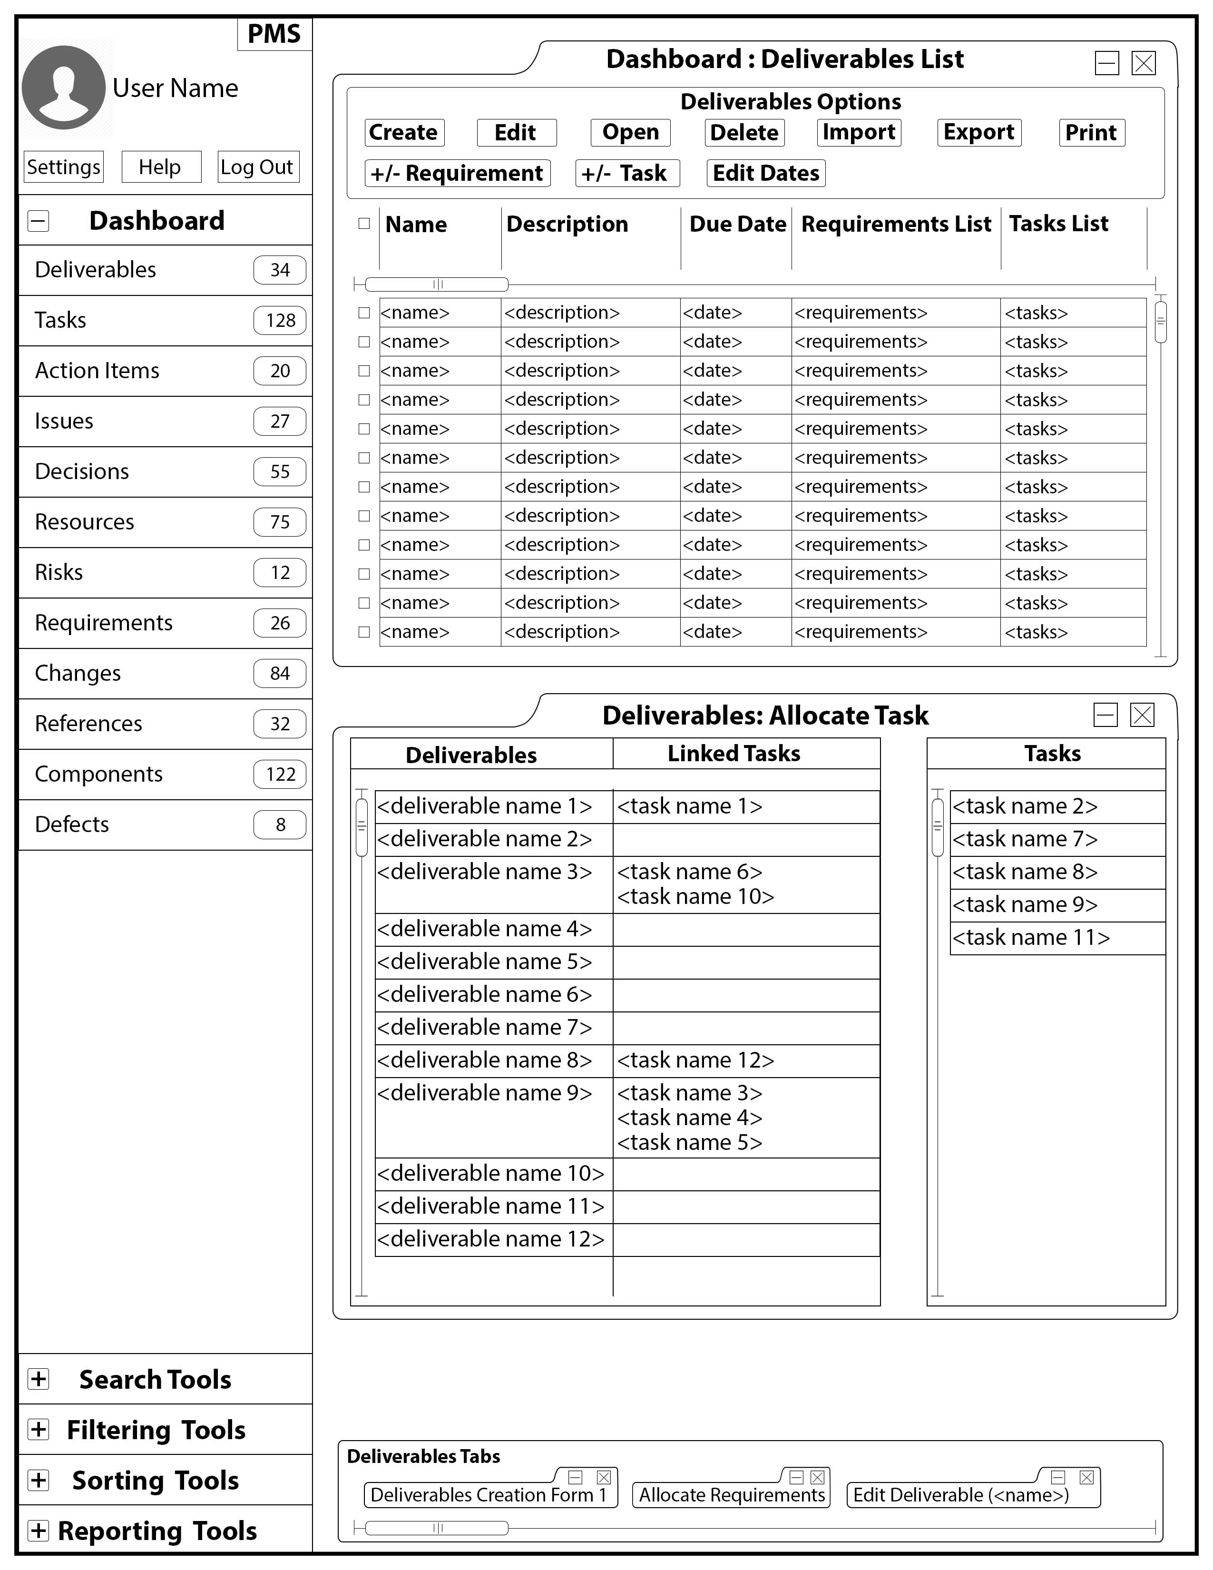

*Figure 1.1.2: Deliverable Creation Form*

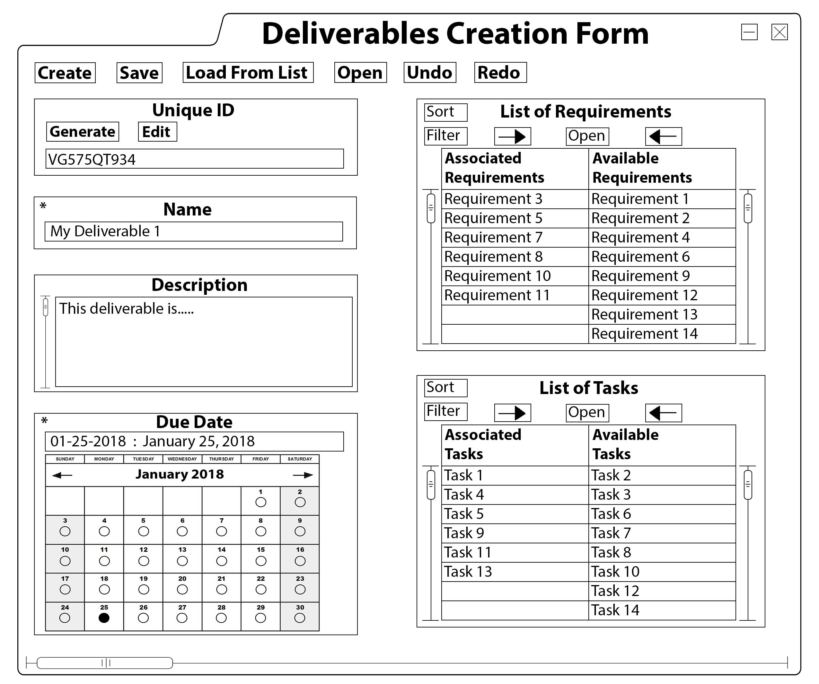

*Figure 1.1.3: Deliverable Item Display*

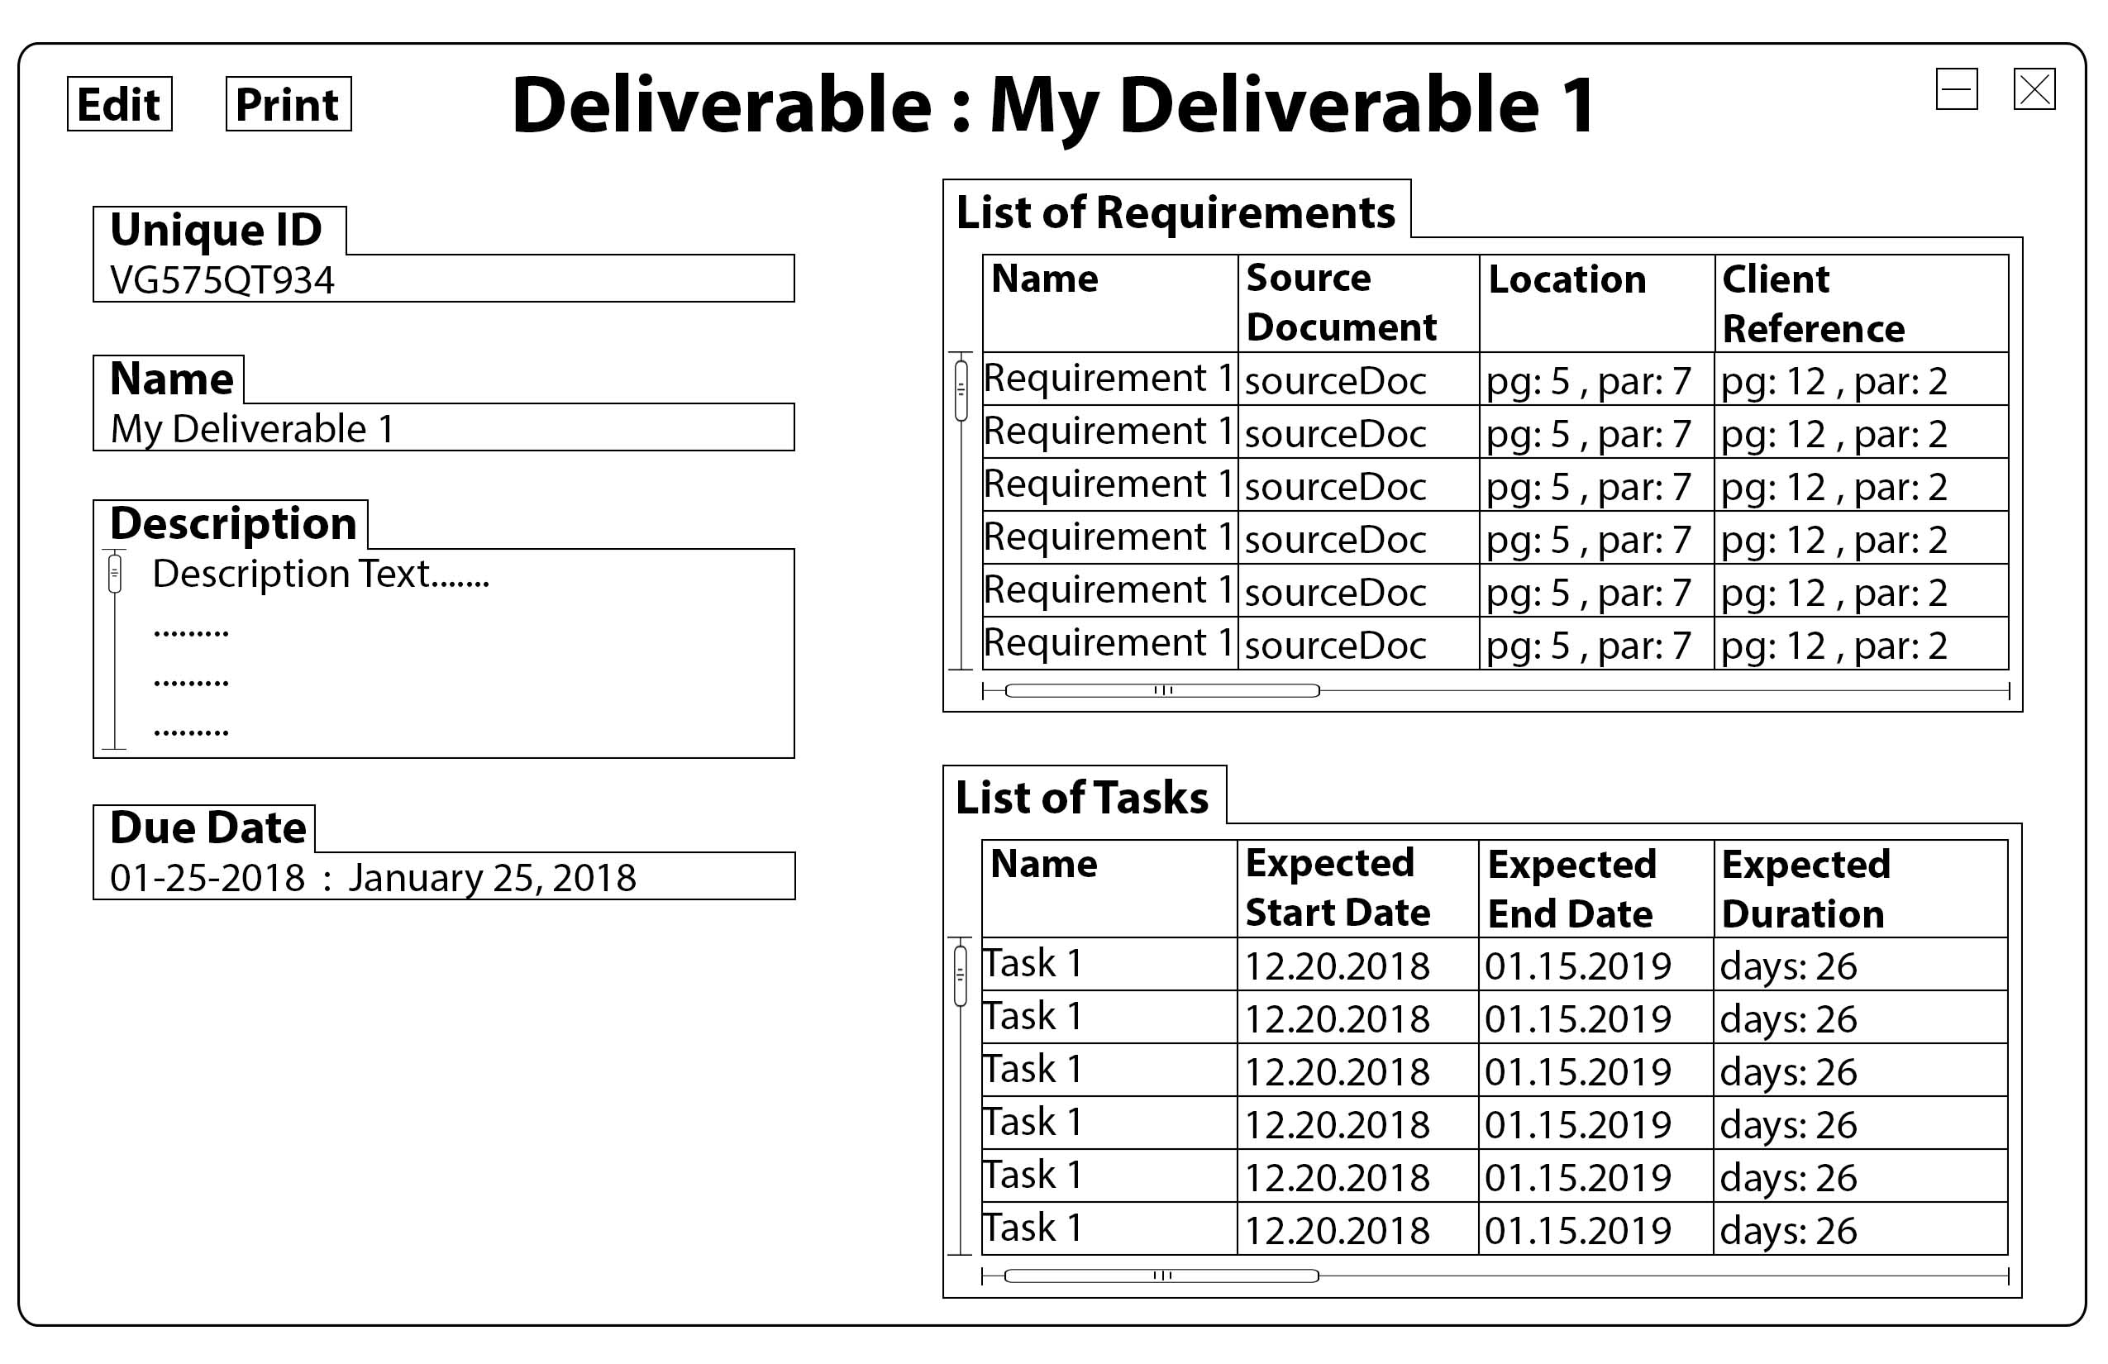

1. **High Level Design**
2. **GUI Prototype**
3. **Detailed Design**

4.1 Entity Relationship Diagram

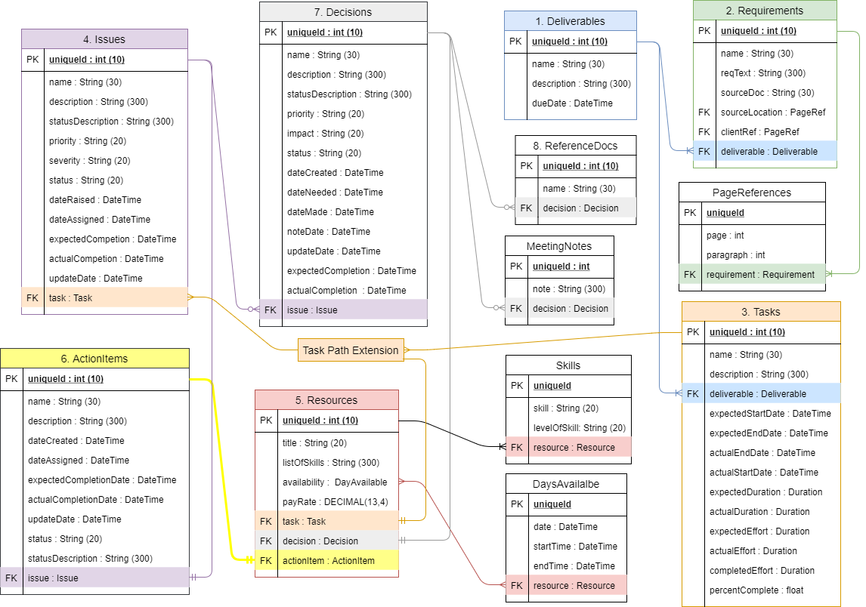

4.2 UML Diagram

4.3 Demo Code and images (Found in the zip file)

1. **Test Cases**
2. **Requirements Cross Reference Matrix**
3. **Code Summary**